COMP-SCI 303 Assignment 2

Part 1 Screenshots

Menu for the functions:

push_front()

push_back()

pop_front()

pop_back()

front()

back()

empty()

insert()

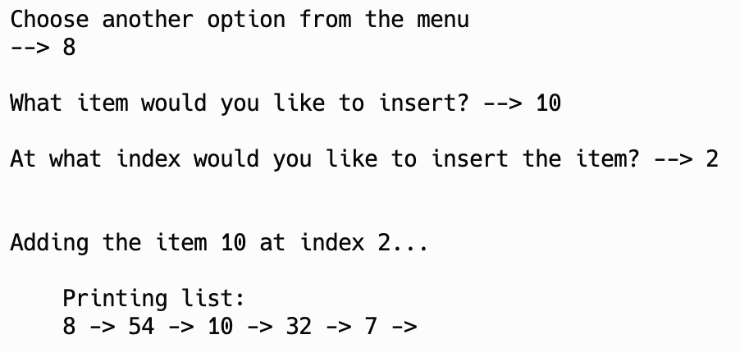

remove()

find()

